A scoping review of privacy and utility metrics in medical synthetic data
Recent studies are using synthetic data as a “silver bullet” but malicious adversary attack could infer info about presence or absence of certain record in the original data. The author thinks more emphasizes are given to utility rather than privacy. The author thinks the synthetic data has yet not been thoroughly scrutinized. Although most papers use synthetic data for data privacy, but some papers use it for data augmentation as well. To evaluate privacy risks membership inference is the most common type, followed by attribute inference, inference based on Classification/regression, holdout set distinguishing, distance to real data, record matching, inference based on matching and ML model inference. Privacy evaluation is mostly revolved around similarity-based metrics, which is also used as a utility metrics, which lead to a conflicting result. It also is inadequate for two reasons. i) similarity != privacy guarantee, there can exist successful inference attacks even if synthetic data is dissimilar from the original dataset. ii) There can exist successful inference attacks even if synthetic data is dissimilar from the original dataset. DP is the most useful as it provides strong resilience against inference attack. Also, international initiative such as IEEE and Horizon Europe’s call for reliable framework in the field. Our review highlights key gaps: a lack of consensus on performance metrics, including conflicting metrics, and an absence of standardized practices for ensuring privacy guarantees.

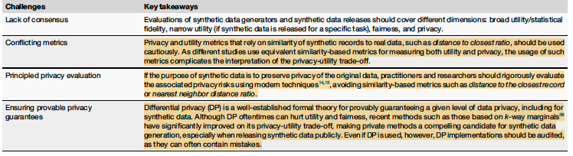
Two key concepts mentioned is Broad utility: we classify as univariate similarity, bivariate similarity, multivariate similarity, or longitudinal similarity. Narrow utility: performance of synthetic data in specific task or context.

A SCALABLE AND GENERAL APPROACH TO DIFFERENTIALLY PRIVATE SYNTHETIC DATA
So here in this paper author has changed the focus from learning and generating the whole synthetic data to query based synthetic data generation where generated data will preserve the measured statistics and overcome the high dimensionality issue. The author approached this in a 3-step workflow: query selection, query measurement and synthetic data generation. The evaluation framework assessed synthetic data utility using three complementary metrics: (i) 3-way marginal accuracy to measure preservation of triple interactions, (ii) high-order conjunction accuracy to test multi-dimensional distribution fidelity, and (iii) domain-specific income inequality statistics to evaluate task-based analytical utility. The authors

Synthesizing Quality Open Data Assets from Private Health Research Studies
Health gan -1
They have some question about the MIMIC-III dataset, they say it’s a database about ICU patients in Boston, so there could be biasness and limited generalization. Also
They also talked about Privacy, resemblance, utility and efficiency metrics in the paper. privacy: how well does the synthetic generation data method preserve anonymity, 2) resemblance: whether the distribution of synthetic data is indistinguishable from the distribution of real data. 3) utility: can research studies be reproduced successfully with synthetic data and 4) efficiency: how practical is the training and generation pipeline.
For generation of data they’ve introduced a novel variant of categorical encoding method where they have used a method to encode ordinal data
One key point about healthgan is you can export the model without the risk of exposing training data. So you can export the generator model without the data, so it doesn’t need the real data anymore.

